

Fortnightly Progress Report

SIDBI – PMU Chhattisgarh

Period – 1st to 15th February 2023

**Project Progress Report – Fortnightly**

|  |  |
| --- | --- |
| **SIDBI State PMU – MSMEs** | |
| **Location: Chhattisgarh**  **Month & Year: January 2023**  **Fortnight Ending: 15th February 2023** | **Report Summary**  This Report includes the activities carried out by SIDBI - PMU for the  facilitation of MSME Ecosystem in the State of Chhattisgarh. |

**Team Deployment Status**

|  |  |  |  |
| --- | --- | --- | --- |
| **Team** | | | |
| **SN** | **Designation** | **Name of Resource** | **Deployment Date** |
| 1 | PMU Manager | Ishwar Kumar | 08th August 2022 |
| 2 | Business Analyst | Shubham Jha | 07th November 2022 |

**Details of State Nodal Connect - Name – Shri Anil Tuteja (IAS), Director Industries, Chhattisgarh.**

**Shri Sanjay Gajghate, Joint Director Industries, Chhattisgarh.**

**Activities performed by PMU during fortnight ending 15th February 2023**

|  |  |
| --- | --- |
| **Activity** | **Details of activities carried out** |
| 1. After conduct of a stakeholder meeting between SIDBI and DIF & Deputy Secretary Finance, Govt. of Chhattisgarh on 20th January 2023, the PMU is actively following up with the DIF & Finance Department for signing of Master Agreement, borrowing approval under Article 293, and signing of RBI Mandate. The DIF & Finance Department have updated that files have been moved with regard to the same and is due for signature from Finance Secretary, after which these can be executed. | |
| 1. The PMU has been trying to mobile stakeholders for applying for a MSE-CDP Cluster Project, since the establishment of the PMU. Recently in the month of February, PMU team has facilitated the Cluster and the Implementing Agency in applying for cluster development under MSE-CDP scheme. The proposal has been submitted online. The PMU is further working with the State Govt. to develop a policy for mobilizing 15% investment for such projects on a case to case basis. In this regard, the PMU has submitted a proposal to the Directorate of Industries. | |
| 1. The PMU is making efforts to contribute in the development of Rural industrial Parks in the state. In this regard, the PMU in collaboration with State Planning Commission organized a stakeholder meeting for seeking productive partnership from the stakeholders, especially agri-inputs companies, farm technology & tools providers, skill partners, rural industries, banks, art & crafts marketing companies, agri-value chain partners, etc. so that an ecosystem for rural industries can evolve in Chhattisgarh. | |
| 1. PMU had conducted meeting with IIM Raipur on promoting Entrepreneurship. In this regard, the PMU has proposed for an MoU between the IIM Raipur and SIDBI for providing financial support to the upcoming startups and also to provide mentorship to other startups in other educational institutions. | |
| 1. PMU team conducted meeting with the CG MFP Federation for supporting first generation entrepreneurs in starting business based on the value addition of minor forest produce. In this meeting, the representative of MFP federation presented different product opportunities and ideas on which there could startup opportunities for investors in the state. In this regard, the PMU has requested the federation to link to interested entrepreneurs with SIDBI/PMU team for bank loans. | |
| 1. The PMU team has proposed for a state level venture capital for supporting and financing the growth stage startups and MSMEs in the state. The PMU team is regularly following up with the concerned officers and departments for its implementation. | |
| 1. The PMU has proposed for conducting a State Level MSME Award to acknowledge and motivate the MSMEs, conducting orientation programme on MSME ecosystem, Mini cluster scheme and state level CGTMSE Scheme for the better growth and development of MSMEs in the state. The PMU team is regularly following up with the concerned officers and departments for its implementation. | |
| 1. The PMU team has made efforts to develop a strong linkage between the local industry and SIDBI by facilitating discussion on green energy financing and other types of loans through the industry associations. The PMU has organized meetings between SIDBI and Urla Industry Associations, Forging Units, Stone Cutting Units, and Chhattisgarh Chamber of Commerce. | |

|  |
| --- |
| **Actionable and Support required** |
|  |
| **Activities Way forward** |
| * Signing of Master Agreement on SCDF * Working on proposals of potential identified clusters * Mapping potential proposal for SCDF through interdepartmental meetings |
| **Inputs of State Nodal Connect / Officer** |
|  |

*****************

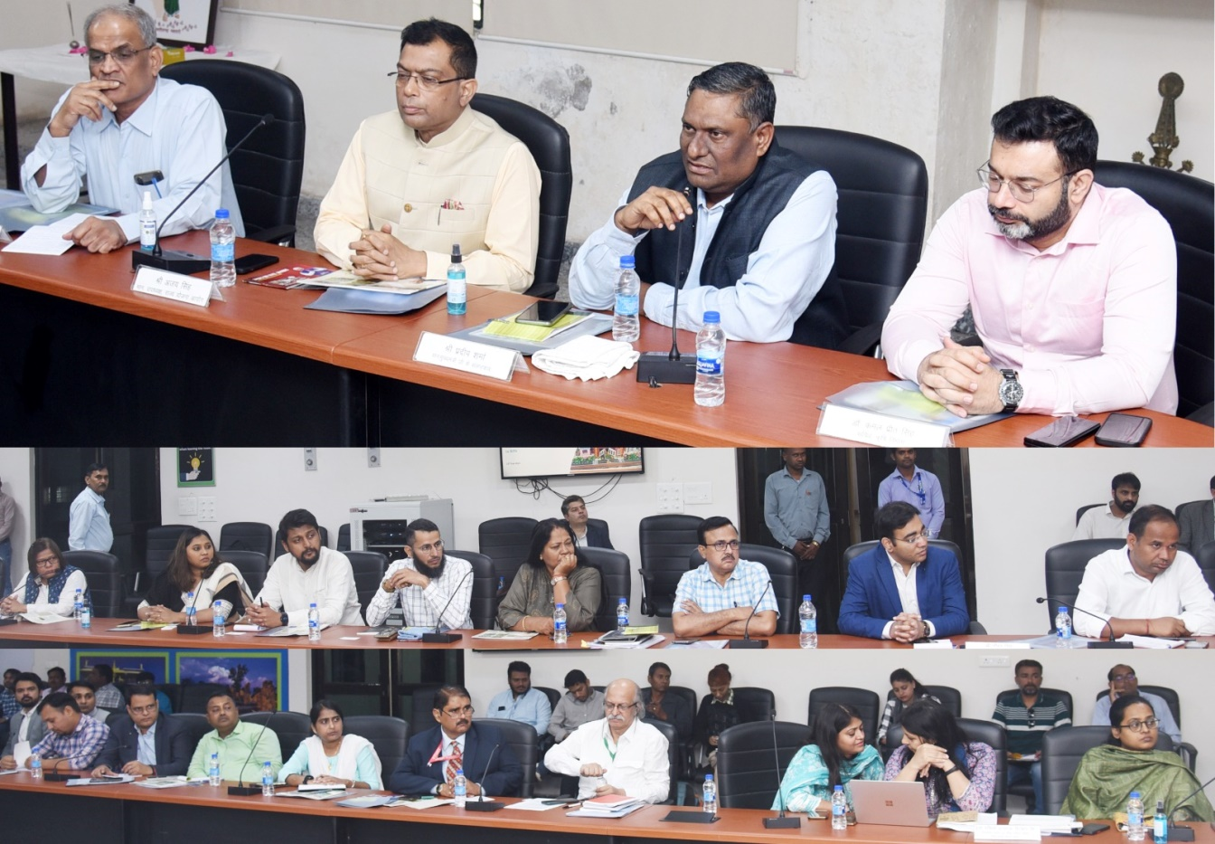

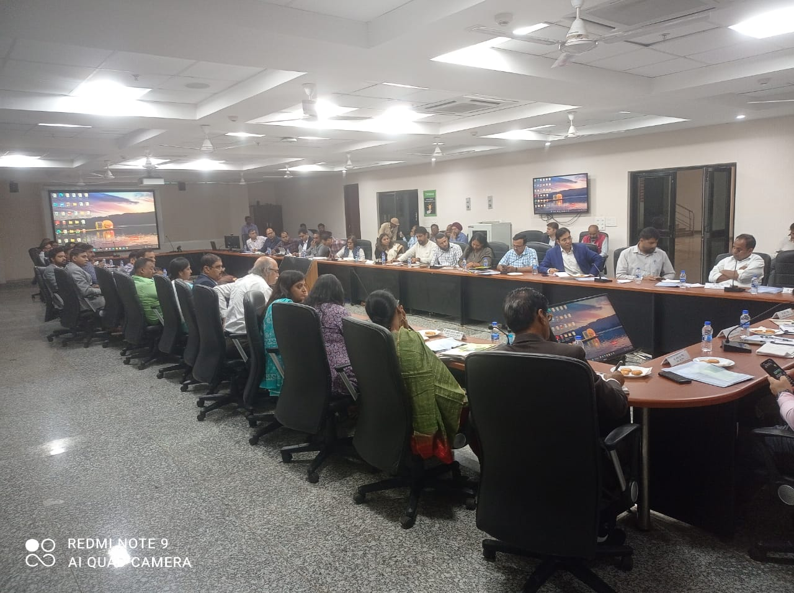

**Contact us**

To know more, please visit [**www.grantthornton.in**](http://www.grantthornton.in/) or contact any of our offices as mentioned below:

|  |  |  |  |  |
| --- | --- | --- | --- | --- |
| **NEW DELHI**  National Office, Outer Circle, L 41, Connaught Circus, New Delhi - 110001 T +91 11 4278 7070 | **NEW DELHI**  6th Floor, Worldmark 2, Aerocity,  New Delhi - 110037 T +91 11 4952 7400 | **AHMEDABAD**  7th Floor, Heritage Chambers,  Nr Azad Society, Nehru Nagar, Ahmedabad - 380015 | **BENGALURU**  5th Floor, 65/2, Block A, Bagmane Tridib, Bagmane Tech Park, CV Raman Nagar, Bengaluru - 560093  T+91 80 4243 0700 | **CHANDIGARH**  B-406A, 4th Floor, L&T Elante Office Building, Industrial Area Phase I, Chandigarh - 160002  T +91 172 4338 000 |
| **CHENNAI**  7th Floor, Prestige Polygon,  471, Anna Salai, Teynampet, Chennai - 600018  T +91 44 4294 0000 | **DEHRADUN**  Suite No 2211, 2nd Floor, Building 2000, Michigan Avenue, Doon Express Business Park,  Subhash Nagar, Dehradun - 248002  T +91 135 2646 500 | **GURGAON**  21st Floor, DLF Square, Jacaranda Marg, DLF Phase II,  Gurgaon - 122002  T +91 124 462 8000 | **HYDERABAD**  7th Floor, Block III, White House,  Kundan Bagh, Begumpet, Hyderabad - 500016  T +91 40 6630 8200 | **KOCH**I  6th Floor, Modayil Centre Point, Warriam Road Junction, MG Road Kochi - 682016  T +91 484 406 4541 |
| **KOLKATA**  10C Hungerford Street, 5th Floor,  Kolkata - 700017  T +91 33 4050 8000 | **MUMBAI**  11th Floor, Tower II,  One International Center, SB Marg Prabhadevi (W), Mumbai - 400013  T +91 22 6626 2600 | **MUMBAI**  Kaledonia, 1st Floor, C Wing, (Opposite J&J Office),  Sahar Road, Andheri East,  Mumbai - 400 069 | **NOIDA**  Plot No 19A, 2nd Floor, Sector - 16A,  Noida - 201301  T +91 120 485 5900 | **PUNE**  3rd Floor, Unit No 309- 312, West Wing, Nyati Unitree, Nagar Road, Yerwada  Pune - 411006  T +91 20 6744 8800 |

For more information or for any queries, write to us at [**contact@in.gt.com**](mailto:contact@in.gt.com)

|  |  |
| --- | --- |
| Twitter-outline | **Follow us @GrantThorntonIN** |

**Small Industries Development Bank of India (SIDBI),** established under an Act of Parliament in 1990, acts as the Principal Financial Institution for Promotion, Financing and Development of the Micro, Small and Medium Enterprise (MSME) sector as well as for co-ordination of functions of institutions engaged in similar activities. In the context of the changing MSME lending landscape, the role of SIDBI has been realigned through adoption of SIDBI Vision 2.0 which envisages an integrated credit and development support role of the Bank by being a thought leader, adopting a credit-plus approach, creating a multiplier effect and serving as an aggregator in MSME space.





***Disclaime****r: This document is prepared under SIDBI intervention in which Grant Thornton Bharat LLP is the implementing agency. The document users/third parties shall verify the facts and figures at their end and shall be solely liable for any action taken by it based on this document. SIDBI, its directors, employees or any office shall not be liable for loss of whatsoever nature arising by using the content of this document.*